# Assignment 2

## Subject: AI Lab

WAP to solve the given water jug problem using BFS.

You are given two jugs with m liter and a n liter capacity. Both the jugs are initially empty. The jugs don’t have markings to allow measuring smaller quantities. You have to use the jugs to measure d liters of water where d is less than n

Code:

# Water Jug problem

MaxA = 5

MaxB = 4

def getChild(node):

    a = node[0]

    b = node[1]

    # print(a, node, node[0], node[1])

    child = []

    # Empty:

    if a != 0:

        child.append([0,b])

        # transfer A to B

        if b < MaxB:

            child.append([max(0, a+b-MaxB), min(MaxB, a+b)])

    if b != 0:

        child.append([a,0])

        # transfer B to A

        if a < MaxA:

            child.append([min(MaxA, a+b), max(0, a+b-MaxA)])

    # Fill:

    if a < MaxA:

        child.append([MaxA, b])

    if b < MaxB:

        child.append([a, MaxB])

    return child

def bfs(start, goal):

    current = start

    q = [start]

    visited = []

    parent = []

    while (len(q) != 0) and current != goal:

        q.pop(0)

        visited.append(current)

        # print(":  child: ",getChild(current), "\n:  current: ",current, ":  queue: ", q)

        for i in getChild(current):

            q.append(i)

        current = q[0]

    path = [goal]

    lv = goal

    for i in visited[::-1]:

        if lv in getChild(i):

            path.append(i)

            lv = i

        else:

            continue

    print("Traversal:",(visited))

    print("Path:",(path[::-1]))

bfs(start=[0,0],goal=[2,0])

Output:

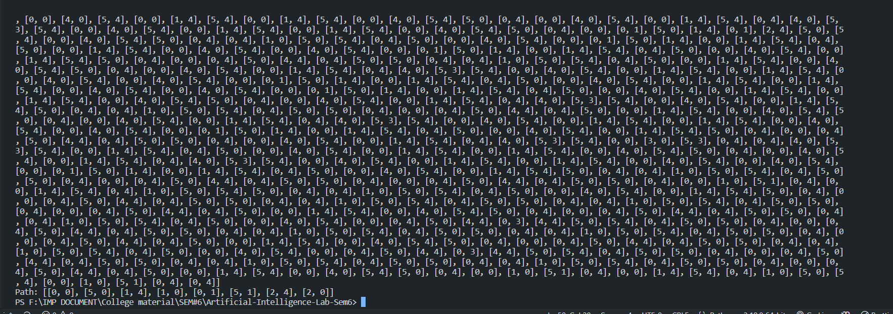

Answer

Path: [[0, 0], [5, 0], [1, 4], [1, 0], [0, 1], [5, 1], [2, 4], [2, 0]]